16.49: a) Combining Eq. (16.14) and Eq. (16.15),

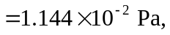

or 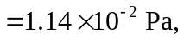 to three figures. b) From Eq. (16.5), and as in Example 16.1,

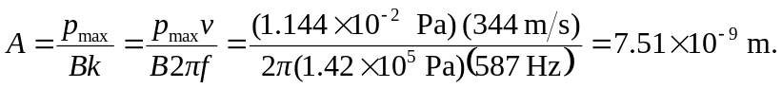

c) The distance is proportional to the reciprocal of the square root of the intensity, and hence to 10 raised to half of the sound intensity levels divided by 10. Specifically,

